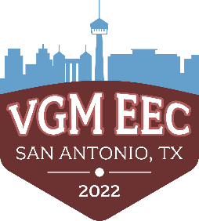

**Executive Education Conference 2022**

**San Antonio, TX**

**November 7-10, 2022**

**Description**

The Executive Education Conference (EEC) is a premier event for our Platinum and 212 members. The first EEC was held in 2006. This event is designed to be educational and provide the optimal environment for networking and building lasting, meaningful connections with our top members and key vendor partners. The location of this event changes each year to provide a new environment and engagement experience. The educational content is structured around key industry challenges and tailored to the C-Suite of the companies. We incorporate fun activities and time out of education to have opportunities for relaxation and networking. Attendees are invited to bring their spouse/ partner / guest as a way to create stickiness to VGM. This is also why we invite our VGM team to also bring their significant other. We know that VGM is great at providing connections and creating relationships. Creating these same connections and relationships with significant others is equally important to the longevity of our members.

**Primary Contacts**

Mandi Joyner, Senior Director of Marketing Taylor Pinero, Events Manager

319-505-3196 319-493-4027

**Hotel Information**

La Cantera Resort & Spa

16641 La Cantera Pkwy

San Antonio, TX 78256

210-558-6500  
<https://www.lacanteraresort.com/>

**Transportation**

A designated person in your transportation group has received a text message with a link to Lyft (see example of text message below). This code will be valid for 24 hours the day of arrival/departure and has already been paid for. Click the link when you are ready to be picked up from/for the airport with your group*.*

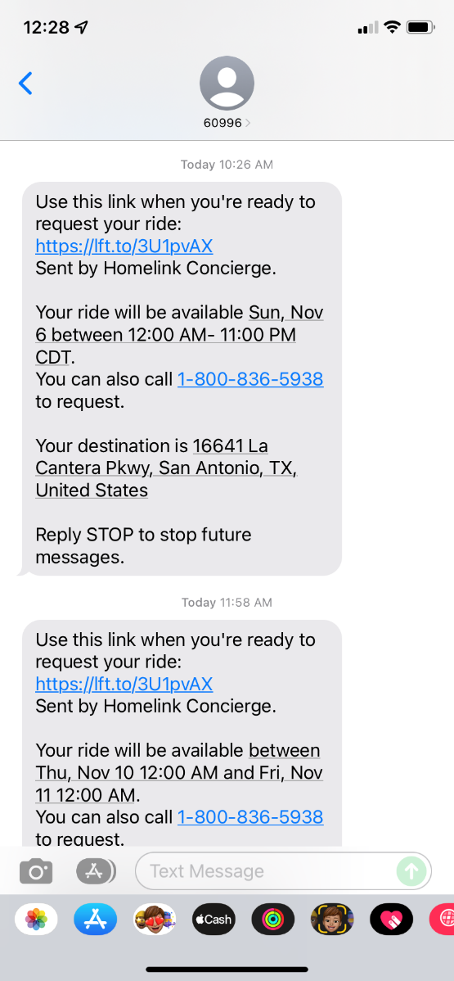This ride will take you to and from the hotel only.

*Please see the assigned carpool groups on the*

*EEC 2022 VGM Attendee & Travel Information Spreadsheet.*

If you have any day of questions or concerns about your Lyft, please contact:

Amanda Bovy: 319-274-7975 (work)

Augusta Pike: 319-236-4581 (work)

**Registration**

Registration will begin Monday, November 7th at 12:00pm. We politely ask that you wear your EEC badge throughout the duration of the event, offsite social events included. Attendees and guests will receive their badges, welcome gifts, and ambassador cards at registration. There will be attendee, guest, speaker, and vendor badges.

VGM employee-owners reminder – if you are not in the office and have not filled out your ambassador cards, you will need to arrive in San Antonio before 11:00am to get your cards and fill them out. If you will not be in San Antonio prior to 11:00am on Monday, please let me know and I’ll fill out your cards for you.

**Attendee and Guest Branded Items**

* The attendee and guest welcome gift (sling bag, water, and snacks) will be handed out at registration to each attendee and guest.
* Attendees will receive a gray notebook and pen that will be placed on tables at the beginning of Tuesday morning.
* Guests will receive a Yeti tumbler Wednesday morning. These will be delivered to guest rooms before Wednesday afternoon activities.
* The attendees and guest thank you gifts will be given out at the Wednesday night dinner. Each attendee will receive a wine tumbler and each couple will also receive a wooden charcuterie board.

**Dress Code**

Business Casual, including social events.

In November, San Antonio averages daytime highs of 72° F and lows in the 50s. In addition to packing for your preferred networking events, we recommend bringing some pieces you can layer. But have fun with your wardrobe. San Antonio is such a culturally vibrant city with eclectic style, so EEC is an opportunity for you to show off your own unique style.

**Agenda At-A-Glance**

***Monday, November 7 – Arrival Day***

After you get checked in at registration and settled in, join us for cocktails, dinner, and after hours in the hospitality suite, all while taking in the San Antonio culture. There will be a wine tasting event of all Texas wines the first night as well.

There will be assigned seating for the first night of the dinner to help promote new connections and friendships. Mandi and Taylor will have the seating list as people arrive.

***Tuesday, November 8 – Day 1***

Start your day with our attendee and spouse breakfast, followed by a full morning of educational sessions focused on data, operational efficiencies, and an exciting keynote.

Spouses will have the opportunity to join in on a tasty challenge called “Taste San Antonio”. Win trivia rounds to gain secret ingredients to whip up your best margarita and guacamole. Spouses can also partake in their spa appointments, activities offered at the resort, as well as nearby shopping!

The evening will include off-site networking and dinner. Networking will be hosted at Hopscotch, an immersive art gallery, and dinner will follow at LDR and The Grotto along the river walk. Upon return to La Cantera, the hospitality suite will be open for continued networking.

***Wednesday, November 9 – Day 2***

Day 2 will feature presentations on negotiating payer contracts, reimbursement, and all things related to money. Speakers will cover best practices, what you need to know, and next steps. Spouses can partake in their spa appointments, activities offered at the resort, as well as nearby shopping.

In the afternoon, we will break from sessions to enjoy the outdoors while networking with peers.

Golf at The Resort Course, La Cantera: Kelly Wolf and Tyler Mahncke

* Driving range opens at Noon!

Mission Trail – Hiking: Sarah Conger, Jeremy and Christy Stolz

Mission Trail – Biking: Barb and Brad Anderson

Mission Trail – Kayaking: Mandi Joyner

Natural Bridge Cavern Discovery Tour: Jenn Alpers

The evening will include a dinner at the Esparza Lawn at La Cantera with Mexican cuisine and a few surprise guests. After dinner, please enjoy after hours in the hospitality suite until midnight.

***Thursday, November 10 – Departure Day***

Pack your bags and say your goodbyes. Everyone will head home… until next time!

*For the full agenda, please refer to the workbook* [*here*](https://s3.amazonaws.com/OnDemandProd/%2F76fa3d987c0323cde0530a093a0a3039/633f2e6f0006107f5dcb5cfd05b60309_635066d8003934e16afd04720f258bf3?response-content-disposition=inline%3B%20filename%3D%2222_685003%2520EEC%25202022%2520Workbook-Attendee-FinalDigital.pdf%22%3B%20filename%2A%3DUTF-8%27%2722_685003%2520EEC%25202022%2520Workbook-Attendee-FinalDigital.pdf&response-content-type=application%2Fpdf&X-Amz-Algorithm=AWS4-HMAC-SHA256&X-Amz-Date=20221031T224650Z&X-Amz-SignedHeaders=host&X-Amz-Expires=60&X-Amz-Credential=AKIASBHFXT6MA5FW354W%2F20221031%2Fus-east-1%2Fs3%2Faws4_request&X-Amz-Signature=80c88576f4e95939b8dcab37c853d2f576bdade0ccba506231df7a9417b00f0d)*.*

**Event Expectations**

**VGM Employee Owner Expectations**

As mentioned above, this is a premier event for VGM members and key vendor partners. Each year the leadership team selects who from VGM should be in attendance based on their knowledge, expertise, and connections within the Industry and VGM. You’ve been selected because you are a key ambassador for VGM and your respective division. Our expectation is that you exemplify the VGM Power of One Principle of providing meaningful, memorable service while at this event and truly hold up the VGM Brand. This means you are respectful, kind, professional, helpful, engaging, etc... You should be interacting and engaging with members and vendors as much as possible. We do also expect you to be at EEC for the duration of the event and attend all activities and educational sessions.

**Guest Expectations**

As a guest of a VGM Employee Owner, you are also the VGM Brand. This does NOT mean you need to know everything about VGM. This does mean that you held to the same standards of the VGM Brand and Power of One Principle including being respectful, kind, professional, helpful, engaging, etc... We do encourage you to engage with other guests as much as possible, especially if you see someone alone. Please plan on attending the Taste of San Antonio Tuesday morning as well as your Wednesday afternoon activity. We would also like you to help us. If you hear of any guest that is unhappy or has suggestions for future events, please let Taylor or Mandi know ASAP.

There will be downtime for you! The guest agenda has built-in free time on purpose because we do want you to have time to relax and unplug. You too, have significant others that put a lot of time, travel, and energy into VGM and we appreciate your support! This means that yes, you can sit by the pool, take a shuttle to the nearby boutiques, or spend extra time at the spa. Again, it would be great if you could find a guest or make a friend that you could take with you, but we also want you to respect that they might want quiet / alone time too.

**Hospitality Suite Guidelines**

Each night at EEC after the more ‘formal’ event time is over, we open a hospitality suite from 9 p.m. - Midnight. This is a suite room in the hotel that we stock with snacks and beverages (alcoholic and nonalcoholic). This is an additional time for everyone to have fun and network in a very relaxed atmosphere. Mandi and Taylor will have the keys to this suite and will make sure it is stocked and prepped for each night. A VGM employee owner will need to close the suite each night. We might tap you on the shoulder to help with this. A member or group of members should never be left without a VGMer in the Suite. A VGM employee owner will need to shut down the suite each night.