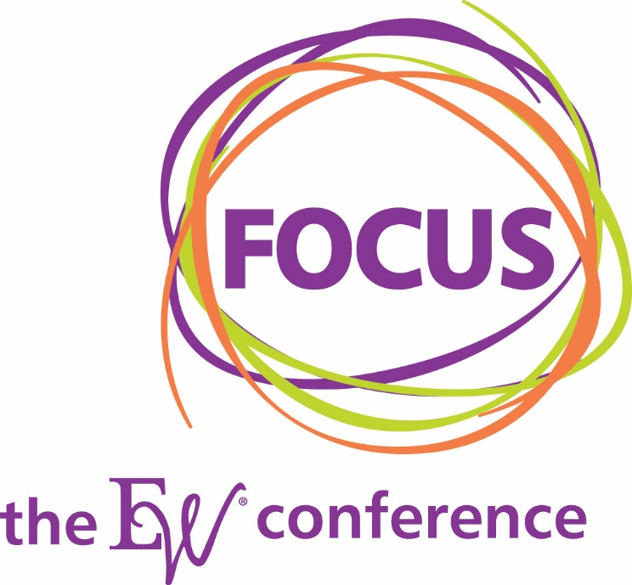

Focus: The EW Conference
Marketing and Operations Plans 2023

Goals:
SALES GOALS:
120 paid attendees
- 2019: 127 paid attendees
- 2020: 160 registered attendees, 83 different companies
- 2022: 106 registered attendees
25 booths sold, $60,000 in sponsorships
- 2019: 23 paid, 10 VGM – 33 total
- 2020: 25 vendors, 31 including VGM
- 2022: 29 vendors, including 4 VGM
- Goal: $60,000 in sponsorships and attendee participation fees
Ruth Addison Award: 20 Nominees
- 2021: 11 Nominees
- 2022: 13 Nominees

MARKETING OBJECTIVES
Key targets: Leadership, billing & reimbursement/operations, compression, mastectomy, mother/baby
Marketing Goals:
- Create leads for follow-up calls to be made by Outbound Communications and EW Team
- Generate awareness of Focus Conference and Ruth Addison Award
- Increased web traffic on focus.essentiallywomen.com
- Registrations

Targeted Audiences:
GROUPS TO TARGET:
- EW Members – All members
  - Secondary audience: VGM only with mastectomy purchases to encourage participation and EW membership
    - Are you interested in building your women’s health business?
    - Put in Connect – want to boost your women’s health business? Attend Focus
      - Oct-Jan: Event Calendar
      - Oct-Nov: Post about Focus and why they should attend
- Vendors
  - Contracted with EW
  - Contracted with VGM
  - Select non-participating

Dates
Feb. 3-4: Pre-conference
- ABC Class

Feb 4 (1-4 p.m.): Pre-Conference
- Billing & Reimbursement 101 Course with Ronda Buhrmester (intake, best practices, billing codes, modifiers, clearing houses, submitting claims)
- Lunch is not included

Feb. 4-6, 2023 at the Sheraton Sand Key Resort, Clearwater Beach, FL

Feb. 4: American Breast Care Reception from 6-9 in Beach/Gulf Room at the resort
- Attendees only
- No specific RSVP from EW, but include on our website
- Marketing comms to tell people what to expect

Pricing
- Full Conference Registration: $275 per person
- On-Site Registration: $350
- Billing & Reimbursement Pre-Con: $50
- On-Site Billing & Reimbursement Pre-Con: $75
- Tradeshow Only: $100

Special Offers
- Early Bird (Sept. 26-Nov. 30): $225 per person
- Early Bird Buy 4 Get 1 Free (Sept. 26-Nov. 30) $180 per person
- Buy 4 Get 1 Free (Dec. 1-Jan. 20) $220 per person
- Early Bird New Member BOGO $112.50 per person
  - Offered to new EW members Feb. 1. 2022 to Jan. 20, 2023
- New Member BOGO $137.50
  - Offered to new EW members Feb. 1. 2022 to Jan. 20, 2023

Hotel Information
Sheraton Sand Key Resort
1160 Gulf Blvd, Clearwater Beach, FL 33767
Rate: $239
Cutoff for reservations – On or before Jan. 10, 2023 (real date is Jan. 12)
Rate is available Feb. 1 – Feb. 11
Hotel Reservation Link:
Registration Opens: 9/26/22

Rooms Utilized:
- Palm/Bay/Island II: Exhibit Hall
- Beach/Gulf: General Session, ABC Reception and Dinner
- Bay/Island II: Preconference Friday and Saturday
- Conch Room on 6th Floor for meeting space
- Coastal Room: Office
- VGM to coordinate ABC Pre-conference and reception/dinner

Marketing Tactics
- Email
  - EW and VGM members who do mastectomy (ABC Purchasers)
- Personal Email
- Email Signature
- Calls – from EW
- Calls – Outbound Communications
- Websites: essentiallywomen.com and focus.essentiallywomen.com
- VGM Website – Event VGM
- VGM Connect – Event and October Blog
- Social Media Posts– 1 per month beginning October
  - Feature a presenter or topic each month
- Facebook Event
- Mailed Prospectus – October
- Newsletter – Each Month beginning September
- eProspectus (digital version) - November
- Postcard – first week of Jan
- Blogs – 1 per month beginning October
  - Feature a presenter or topic each month
- Buckslips with quarterly statements – Q3 and Q4

Messaging & Positioning:
Focus Conference will be positioned as:
- The best show for education, networking and hospitality
- Major benefit of membership
- Place for members to recharge and gain valuable knowledge to do business better
- Premier education
  - Two Keynotes
  - Earn CEUs, scientific and business
  - More scientific sessions (once approved)
- Exhibitors, exhibit hall
  - An innovative show – see the latest technology
  - See what’s new and take advantage of show specials
- New this year:
  - Pre-conference session with Ronda
  - Cocktail reception for Exhibit Hall Grand Opening on Sunday evening
  - Topics include mastectomy, billing & reimbursement, menopause and breast cancer, patient perspectives and best practices
- Pricing breaks
  - Early Bird Full Conference Registration: $225 per person
  - Early Bird with Billing & Reimbursement Pre-con: $275
  - Full Conference Registration: $275 per person
  - Registration with Billing & Reimbursement: $350
  - On-Site Registration: $350
  - On-Site with Billing & Reimbursement: $425
  - Tradeshow Only: $100
  - Buy 4 get 1 free
- Attendee Comms:
  - Flip flop party? Remind of temps, don’t wear heels on the beach
  - Program or email to include recommended restaurants

Implementation/Frequency:
- Press release
  - Late September: Registration Open and Speakers Announced
  - October: Nominations for Ruth Addison Award Open
  - November: Finalists for RA Award
  - December: Keynotes Announced
  - February: RA Award Winner
- EW Calling Campaigns: Ongoing topic Sept through Feb.
- Buck Slip – Q3 (mid-Sept) and Q4 (mid-Nov)
- Flyer: One – to be distributed by EW, ABC, VGM Insurance, VGM RAMs and MAMs - October
- Mailed Prospectus and eProspectus: November
- OBC Calling Campaigns: Early November and Early January
- Email campaign
  - Sept 27– Save the Date
  - Late Sept – Registration Open
  - Sept 27 – Dec 31: Emails on first and third Tuesday (8 emails)
    - Sept 27, Oct 4, Oct 18, Nov 1, Nov 15, Nov 29, Dec 6, Dec 20
    - Sept-Feb RA Award
  - Jan: Emails on 1st, 2nd, and 3rd Tuesdays (3 emails)
    - Jan 3, Jan 10, Jan 17 (last chance)
- Social
  - Sept through Dec: 2nd and 4th weeks of each month
  - January through Conference: Weekly
  - Facebook Event
    - Sept through Dec: 1 post on the event page per month
    - January: post details as needed, goal: two posts in January
- Discussion Board - Monthly
- Blog – Monthly in EW Newsletter beginning Oct.
- Hero/Banner Ad on EW Website, Focus website – Sept-Feb
- Email Signature – Sept-Oct: Register Now early bird registration, Nov-Feb: Register Now, Book your room before room block is full
- Events Calendar on vgm.com – Sept-Feb
- Connect Events Calendar in VGM Connect

Other Marketing/Collateral Needs
Focus Conference PowerPoint (Sept for Oct distribution)
Exhibitor/Sponsorship Packet/Flier
Focus Conference Program
Nametags
Signage
VGM Staff shirts for party
Focus Conference Staff apparel

Focus Education
Focus 2023 Education Steps
- Create a list of potential speakers (July/August)
- Create Microsoft Form to gather speaker submissions (August)
- Solicit applications to speak (August)
- Select speakers and sessions (August/September)
- Confirm speakers and determine date and time of each session (August/September)
- Obtain photos, bios, session learning objectives, overview paragraph (August/September)
- Provide presentation background (October)
- Submit Conference for CEUs (October)
- Assist with developing room monitor schedule (Nov)
- Main contact for Keynotes (Dec, Jan)
- Communicate Focus Details (Nov, Dec, Jan, Feb)
- Obtain final presentations and handouts (December/January)
- Arrange presentation needs (December/January)
- Place session PowerPoint files on session laptops (Feb at Show)
- Responsible for A/V in education sessions

Exhibitors and Sponsors
Steps to secure exhibitors and sponsors for Focus 2023
- Determine pricing, sponsorship opportunities (Sept)
- Prepare tradeshow rules and regs packet (Sept)
- Determine vendors to invite (Sept)
- Determine how vendors will register and collect payment (Sept)
- Solicit and select exhibitors and sponsors (Sept - Dec)
- Determine layout of the show floor and assign booths (Oct - Dec)
- Notify exhibitors and provide exhibit house info (Nov - Dec)
- Double check info from exhibitors for program (Dec/Jan)
- Obtain list of booth staff for nametags (Dec/Jan)
- SALE OF BOOTH SPACE AND SPONSORS MUST END 12/15/22 DUE TO MARKETING DEADLINES
- Vendor payments due 12/31/22

Operations Activity:

September 2022
- Create a list of potential speakers
- Create a form to gather speaker applications
- Discussion Board Post
- Invite speakers
- Review speaker submissions
- Select speakers and sessions
- Obtain speaker collateral
- Determine vendors to invite
- Build and Open Vendor Sponsorship
- Create Attendee registration
- Build and Finalize Schedule
- Review speaker submissions
- Select and confirm speakers and sessions
- Obtain speaker collateral
- Provide presentation background to speakers
- Build and Open Vendor Sponsorship and Exhibitor registration
- Build and Finalize Attendee Registration
- Solicit Exhibitors and Sponsors
- Opportunities: Create in CRM
- EW Community Calls begin
  - New Members since 2/1/22
  - Past Attendees 2019-2022
  - Top Tier

October 2022
- Finalize schedule
- Submit Conference for CEUs
- Solicit vendors for exhibiting and sponsoring
- Calls
- Discussion Board Post

November 2022
- Solicit exhibitors and sponsors
- Finalize Exhibitors and Sponsors, shut down registration
- Notify Exhibitors and Sponsors of deadlines for commercials, any collateral need for buyers guide or sample box
- Calls
- Discussion Board Post

December 2022
- Any sample box items due 12/31/20
- Gather and confirm information for Buyer’s Guide is in
- Calls
- Discussion Board Post

January 2023
- Continue calls
- Prep Focus meeting materials
  - Note Sheets
  - Attendee lists
  - Create room monitor schedules and host trainings

February 2023
- Handwritten thank you notes to speakers, exhibitors and attendees
- Submit conference to ABCOP/BOC week of March 7

Marketing Activity by Month (BASIC)

September 2022
Sept 14: Save the Date Mention in Newsletter
Sept 14: Save the Date Social Post
Sept 14: Discussion board Save the Date
Sept 27: Email 1 Registration Open
Sept 27: Registration Open Social Post
Sept 27: Registration Open Press Release
Prep Ruth Addison Award Timeline (separate document)
Prep Exhibitor/Sponsorship Packet/Flier
Enter job for updated Focus PPT Background
Update Focus Website
Prepare tradeshow rules and regs packet
Prep Flier for Sales Use, in-hands End of Sept
Update Speaker Schedule on Website

October 2022:
Oct 4: Email 2
Oct 12: Newsletter - Blog
Week of Oct 17: Social
Oct 18: Email 3
Oct 20: Discussion Board
Oct 27: Important Updates
Prep OBC Script
Prospectus email and mailed
Connect submission

November 2022
Early November: OBC Campaign
Nov 1: Email 4
Week of Nov 8: Social 5
Nov 9: Newsletter - Blog
Nov 15: Email 5
Nov 17: Discussion board
Week of Nov 21: Social
Nov 20: Email 6

December 2022:
Dec 6: Email 7
Week of Dec 12: Social
Dec 14: Newsletter
Dec 20: Email 8
Dec 22: Discussion Board
Week of Dec 27: Social
Prep all signage
Nametags

January 2023:
SHIP DATE: JAN 6
Early January: OBC Campaign
Jan 3: Email 9
Week of Jan 2: Social 8
Jan 10: Email 10
Jan 11: Newsletter
Week of Jan 11: Social
Jan 17: Email 11 – Last Chance
Jan 17: Discussion Board
Week of Jan 16: Social
Jan 30: Know before you go attendee email
Week of Jan 31: Social

February 2023:
Feb 2: Welcome to Focus
Feb 7: Thank You Email to Exhibitors and Attendees with Survey
Feb 8: EW Newsletter

