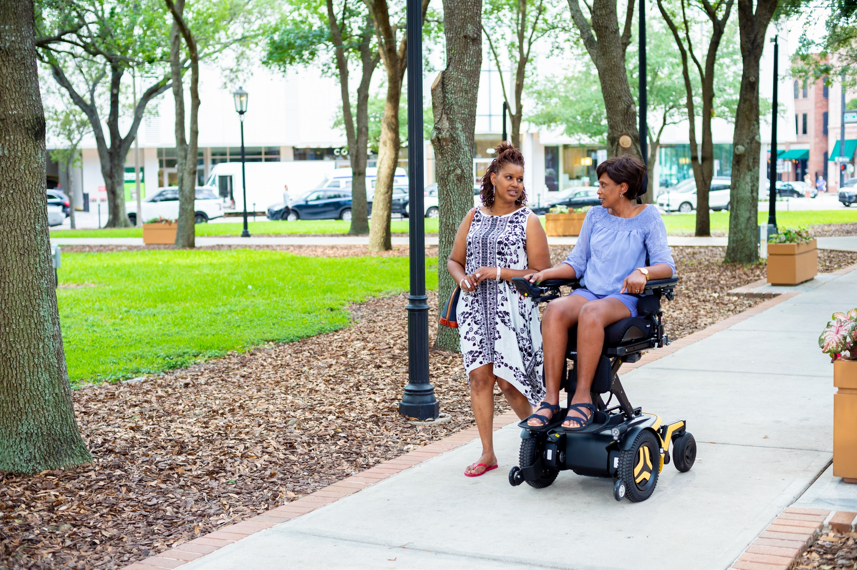

SEAT ELEVATION TALKING POINTS:

1.
Thank CMS for their proposal and support the Benefit Category Determination and coverage decision.

2.
Recommend extension of coverage proposal to improve reach & line of sight to support shoulder, upper spine, and neck integrity.

3.
Support access to seat elevation for users of Group 2 power wheelchairs.

4.
Seek clarity on proposed limitations of “weight-bearing transfers” and evaluation criteria.

Submit your comments by March 17!

Talking Points for Organizational Comments on Seat Elevation NCD
- Thank CMS for their proposal and support the Benefit Category Determination and coverage decision.
- The proposed NCD determines that seat elevation systems in Group 3 power wheelchairs are primarily medical in nature and so fall within the Durable Medical Equipment category. This is the first time Medicare has recognized these systems as DME.
- The NCD also proposes to find that these systems are reasonable and necessary for Medicare beneficiaries using Group 3 power wheelchairs when they:
  - Perform weight-bearing transfers in the home to/from their wheelchair, with or without the use of caregiver assistance or assistive technology, AND
  - Undergo a specialty evaluation by a practitioner with specific training and experience (e.g., physical and/or occupational therapists) in rehab wheelchair evaluations.
- The ITEM Coalition strongly supports the proposed decision, which would dramatically increase access to this critical technology for beneficiaries who spend all or most of their time in a Group 3 chair. This will be a major victory for the disability community and will advance health equity in the Medicare population.
- The ITEM Coalition is also seeking two important inclusions to the proposed decision – coverage for reach & line of sight, and coverage for Group 2 wheelchair users.

- Recommend extension of coverage proposal to improve reach & line of sight to support shoulder, upper spine, and neck integrity.
- The ITEM Coalition urges CMS to include Group 3 wheelchair users who would benefit from increased reach and improved line of sight provided through seat elevation in the final NCD.
- CMS limited its own evidence review to only clinical studies regarding transfers; the agency should conduct a comprehensive evidence search to fully consider other benefits of seat elevation, including reach and line of sight.
- The evidence base, subject matter expert consensus, and patient-centered outcomes data all support the medical benefits for reach and neck positioning/line of sight in the built environment.
- The initial NCD Request submitted by ITEM Coalition cited numerous studies of the benefits of improved reach and line of sight for shoulder, neck, and upper spine function.
  - Seat elevation supports reduction of musculoskeletal disorders in shoulder, upper spine, and neck by limiting the need to constantly reach over one’s head and look up;
  - Seat elevation reduces neck pain and discomfort by improving line of sight;
  - Improved reach and line of sight through seat elevation makes performance of mobility-related activities of daily living (MRADLs) safer for wheelchair users.
- Commenters can reference the previous and forthcoming submissions by the ITEM Coalition and the Clinician Task Force citing the body of medical evidence supporting these functions for seat elevation.
- Reach and line of sight are critical and necessary to improving wheelchair users’ health, safety within the home, and quality of life and beneficiaries should be able to access seat elevation to address these needs.
- Support access to seat elevation for users of Group 2 power wheelchairs.
- CMS has indicated they are considering inclusion of users of Group 2 power wheelchairs for seat elevation coverage. The ITEM Coalition strongly supports this inclusion.
- While the equipment and standards for Group 2 wheelchairs are different from Group 3, people using Group 2 power wheelchairs who need seat elevation should qualify for coverage under Medicare.
- The Group 2 population typically includes people with certain chronic medical conditions impacting cardiovascular and pulmonary function (e.g., congestive heart failure, osteoarthritis, and COPD), lower extremity Acquired Loss of Limb(s), autoimmune diseases (e.g., Inclusion Body Myositis, Lupus, Myasthenia Gravis, Rheumatoid Arthritis, Scleroderma, etc.), and (Poly)Neuropathies. This differs from the Group 3 power wheelchair user population who have a congenital skeletal deformity, myopathy, or neurological diagnosis.
- If their mobility is limited to the point where seat elevation would be reasonable and necessary for their medical needs, they shouldn’t be boxed out just because they don’t fit into the specific diagnoses that fit under the Group 3 coverage criteria.
- Seat elevation can help Group 2 power wheelchair users safely transfer to/from their power wheelchair and gain access to the vertical environment to perform MRADLs, like toileting, bathing, and grooming. Seat elevation provides a basis for level transfers to reduce upper extremity strain during lateral transfers and lower extremity strain during “sit-to-stand” transfers.
- Many Medicare beneficiaries aged 65 and older live alone, are deemed a high fall risk or have fallen while standing or with attempts to stand and subsequently perform their MRADLs from a seated position. If CMS extends coverage for seat elevation to include Group 2 power wheelchairs the minimum height of the seat elevation system must be high enough (at least 6”) for people to safely reach the surfaces and items they need to access within the home to cook, clean, and take care of their hygiene and grooming needs.
- Seek clarity on proposed limitations of “weight-bearing transfers.”
“Weight-Bearing Transfers”: The ITEM Coalition is seeking clarification on CMS’ proposed definition of “weight-bearing transfers” and beneficiaries that might be excluded from coverage based on this definition.
- Patient Transfer Devices: The ITEM Coalition is also seeking clarification on whether beneficiaries who use a patient transfer device such as a floor or ceiling-mounted lift to transfer in and out of their wheelchair would qualify for coverage of seat elevation under this proposed NCD.
- Evaluation Criteria: The ITEM Coalition recommends that the evaluations for seat elevation, including qualifications and criteria for the practitioner conducting the evaluation, be consistent with the current requirements for similar evaluations performed for CRT wheelchair bases and other power seating functions covered by Medicare.
- The ITEM Coalition calls on CMS to clarify these questions and ensure that all beneficiaries who would benefit from seat elevation are able to access coverage under the final NCD decision.

How to Submit Comments:
For a simple guide through the comment submission process, please visit www.Rise4Access.org. Comments are due by Friday, March 17.
Note: Comments must be submitted as plain text directly into the CMS comment portal; no attachments are allowed. You can copy and paste from a document into the portal.

Questions? Contact Joe Nahra, ITEM Coalition Co-Coordinator, at Joseph.Nahra@PowersLaw.com

